SWASTHYA SENSE — Future Updates & Roadmap
Oct 31, 2026 · @Shama

1. Vision and roadmap
The prototype proves the idea on synthetic data; the roadmap shows how it becomes a tool that frontline workers and clinicians can safely use. Each phase ends at a gate (a sign-off or review), so no phase starts on clinical, privacy or legal ground that has not been checked.
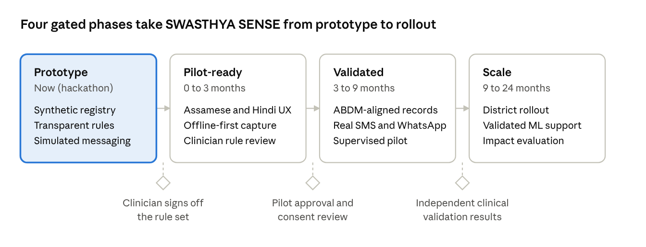
roadmap · 4 phases, 3 gates
The long-term goal stays the same throughout: help workers reach the right patient at the right time, and help clinicians see exactly why a case reached them. SWASTHYA SENSE remains a decision-support and coordination tool, never a diagnostic one.

2. Near-term: pilot readiness (0 to 3 months)
Update | What it adds | Why it matters
Clinician rule review | A doctor or senior nurse reviews and signs every rule and threshold; placeholders are replaced with locally approved ones | Turns the illustrative rules into clinician-owned protocols
Assamese and Hindi UI, voice-friendly prompts | Full translation of worker screens and message templates; optional audio prompts for low-literacy users | Usability for real frontline workers
Offline-first capture | Check-ins saved on the phone and synced when the network returns, with conflict handling | Patchy connectivity is the norm in many field areas
Real SMS pilot adapter | One real gateway behind the existing messaging interface, with DLT-compliant templates | Replaces the simulator without changing other modules
Worker training mode | In-app walkthrough and a practice sandbox with synthetic patients | Faster adoption, fewer errors
Better supervisor tools | Reassign caseloads, bulk reminders, weekly summary | Keeps groups running smoothly
Security hardening | Penetration test, secrets management, backup and restore drills | Prepares for real data handling
Exit gate: a clinician signs off the rule set, and an independent review confirms access control and audit work as designed.

3. Mid-term: integrations and validation (3 to 9 months)
Update | What it adds | Why it matters
ABDM-aligned records | Optional linking with ABHA identifiers and consent-managed record sharing, following current ABDM specifications | Avoids duplicate records and gives clinicians history, with patient consent
WhatsApp Business messaging | Approved templates, richer replies, optional images for measurement entry | Reaches patients on the channel they already use
Device and home-measurement input | Manual entry first, then validated home BP and glucose devices | More frequent, more reliable data
Expanded cohorts | TB follow-up, child nutrition and immunization, mental-health check-ins with extra safeguards | Same engine, wider impact
Referral network | Directory of facilities with capacity, referral slips and outcome confirmation | Closes the loop after escalation
Analytics for programme managers | De-identified dashboards: follow-up completion, time to clinician response, escalation outcomes | Shows whether the system works, and where it fails
Supervised field pilot | One block or PHC area with a small group of workers and a named clinician lead | Real-world usability and safety evidence
Exit gate: pilot approval from the health authority and an ethics and consent review, with a written plan for incident reporting.

4. Long-term: scale and validated intelligence (9 to 24 months)
Update | What it adds | Guardrails
District-level rollout | Multi-facility setup, tenant isolation, hierarchy of supervisors | Same RBAC and audit model at larger scale
Trend and anomaly support | Statistical or machine-learning models that suggest which patients may need earlier attention, shown beside the transparent rules | Trained on real data under approvals; clinically validated; shown as suggestions with reasons; never replaces rules or clinician judgement; bias and drift monitoring
Natural-language and voice check-ins | Patients report symptoms in their own language by voice or text; the system maps them to approved symptom codes | Human confirmation for anything that raises a clinical alert
Interoperability | Standards-based exchange (such as FHIR) with state and national health systems | Consent-driven, minimum data only
Resilience | Multi-region hosting, disaster recovery, SLA monitoring | Documented recovery targets
Open rule library | Shareable, clinician-reviewed rule packs per condition and region | Versioned, signed, with a changelog
Impact evaluation | Compare follow-up completion and time to care with and without the platform | Independent evaluation, published results
Principle for any future model: it may add a second signal beside the rules, but it must explain itself in plain words, be validated by clinicians on local data, and be switchable off by an administrator without breaking the rest of the system.

5. Regulatory, ethics, clinical validation and governance
This section lists the checks the team would need before touching real patient data. They are planning items, not legal advice; each needs review by qualified legal and clinical advisers.
Area | What we would do
Data protection | Review obligations under India's Digital Personal Data Protection Act, 2023 and its rules: lawful basis and notice, consent management, retention and deletion, breach response, grievance contact
Health data standards | Align with ABDM consent and data-exchange requirements before any record linking
Medical-device status | Get an opinion on whether any future feature, especially model-based suggestions, would count as medical-device software under the Medical Devices Rules, 2017, and design to stay on the right side of that line
Clinical safety | Appoint a clinical safety lead, keep a hazard log, define incident reporting and a rollback plan for rules
Ethics | Institutional ethics review for any pilot; follow ICMR guidance on ethical use of AI in healthcare
Clinical validation | Compare flags against clinician judgement on retrospective data, record sensitivity and false alarms, and publish limitations
Rule governance | A named clinical committee approves, versions and retires rules; every change has an approver and a date
Equity and access | Test usability across languages, literacy levels, gender and disability; track who is not reached
Worker welfare | Keep workload realistic, avoid punitive use of dashboards, involve workers in design
Non-negotiables carried from the prototype: no diagnosis claims, a human clinician on every clinical alert, transparent rules with versions, consent before data, least-privilege access, and a complete audit trail.

6. Sustainability, partners and impact metrics
Who could adopt and fund it
- State and district health missions and PHC networks (primary users and buyers).
- NGOs and community-health organizations already running ASHA support programmes.
- Medical colleges and hospitals as clinical-review partners and validation sites.
- CSR and public-health grants for pilot funding; open-source release of the rule engine to build trust.
Cost principle: run on low-cost cloud and SMS or WhatsApp channels, keep the app lightweight for entry-level phones, and charge programmes per active worker rather than per patient.
Impact metrics to report from the first pilot
Metric | Why it matters
Share of follow-ups completed on time, before and after | Direct measure of the problem we target
Median days from due date to contact for overdue patients | Shows speed of response
Median time from clinical alert to clinician acknowledgement | Tests safe escalation
Share of flags that a clinician judged worth reviewing | Controls alert fatigue and rule quality
Worker time spent per patient per week | Frontline usability
Consent withdrawals and complaints | Trust and privacy signal
Coverage by language, village and gender | Equity check
Publishing these numbers, including the ones that disappoint, is part of the plan: it is how SWASTHYA SENSE earns clinical and community trust.

